Dear Diary,

I had this dream that I just woke up from where I was afraid that the world was going to end because something to do with Trump being president (he’s getting inaugurated tomorrow). But then I went to my mom’s work (which was like a terrible sweatshop in my dream…. Is that a metaphor for something..??) Either way, then I went out with some friends I didn’t know that well after, I think that Kayla and Morgan and maybe one other girl I know really well were there though. We went to a Flume concert and it was a super low key one, enough to where he would come into the audience (it was like a movie theatre) and talk with us. He even had this little straw contraption that he put together that turned into a piece and we all smoked with him. I was drunk a little in the dream too, but I think that faded quickly. Then Kayla (guillory) got asked to do a dance number up there with him which was so dope. And I made a ton of friends in the audience. Then, Flume was leaving and wanted my friends and I to come with him, and we sprinted to his next show where I made more friends. Then afterwards, he and I ended up in this big and awesome room and we totally slept together, but it was so amazing. It was so much fun and super sensual and we kept our clothes on for a long time but were just kissing and laughing and he was so into it and it was just so much fun… I don’t think I’ve had that much fun hooking up with someone ever. I did not want to wake up from that dream…. But of course I did.

I think that the sex might have been a metaphor for Maxwell a little bit. He and I have such amazing sex. It’s different, I wouldn’t say that it’s necessarily the most pleasurable sex ever (but then again no sex has really been all that pleasurable for me lately… maybe I’m just not as into it as I used to be). But it’s so intimate and fun with Maxwell. We make so much eye contact and he tells me he loves me and I tell him I love him and we smile and laugh and jokingly talk dirty sometimes, and try new positions, and we are just so open. Maxwell is so selfless too, he literally never ever finishes. He is the only guy I know that just won’t because he wants to do everything for me. Did I tell you about his christmas gift for me? He made me a bunch of jars that were really cute and glass. In some of them it was cool bracelets or trinkets and he put a little quote or small poem with it. Then he had a big jar of folded up notes for me to read whenever I’m having a bad day. He hand wrote all of them and was so fucking thoughtful… Then he gave me like 20 of those wrapped stones for me to either sell or to give to friends, and two giant ones that I need to decide what to do with. Then he paid for us to get a couples massage and spa day at this spa on the top of the mountain resort at snowbird which cost him like 300 dollars and then we went to a nice dinner which I finally convinced him to let me pay half of. But holy shit!!!! Writing all this down is making me realize even more how amazing he is… He wrote a poem for me and about me, but it’s only a draft right now so I won’t write it in here yet, it made me want to write a poem about him though. I’ll put a screenshot that I took of it in here in a second. I wrote it on the plane back to Cali after break, the sun was setting and I was feeling nostalgic and emotional and I’m pretty happy with the poem actually.

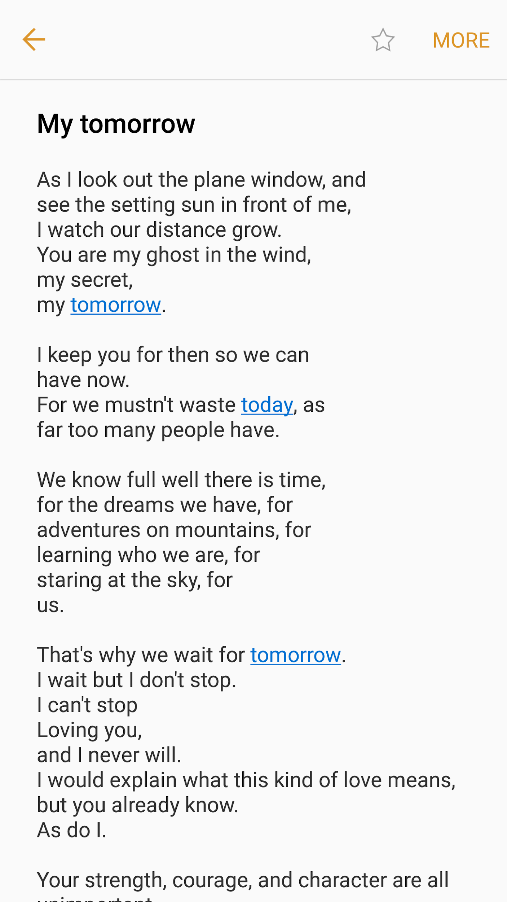

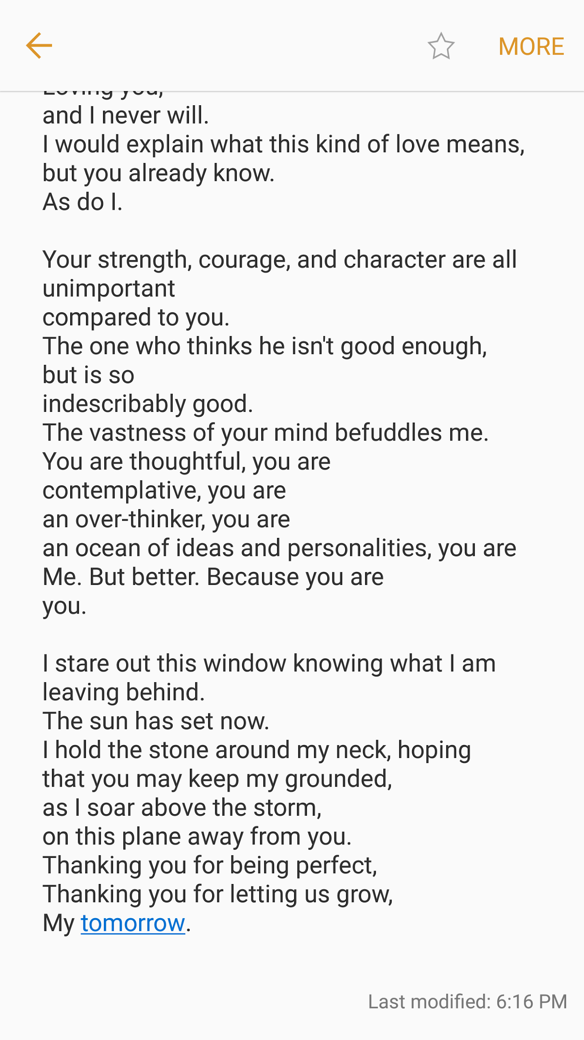

Anyways, that’s the poem. I really do care so much for Maxwell. He is so amazing to me and we are so so similar and I love spending time with him and having all of these crazy realizations and becoming the person that I really want to be and figuring out more about myself through him. It’s weird not having any expectations for a future though. He wants me to travel with him, which does sound very fun. But I also need to travel alone first. And John wants me to be with him, and Nick wants me to be with him. I think that’s it right now.

It’s so nice to have so many people that I can share my life with. But it’s also just so crazy.

Like my dream last night.

I think that my subconscious is enjoying making metaphors for my life right now.

What a poetic diary entry.

Anyways, I need to get ready for class now. Hopefully that is some food for thought for me now that I’ve processed it a little bit.

Flume is amazing.

Maxwell is incredible.

Until next time,

Jessie J. Smith